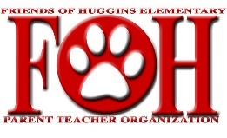
Friends of Huggins 2019-2020
Vote for New FOH Board
May 18, 2020

Approval of 2020-2021 FOH Board

- Motion to approve 2020-2021 Board members by Courtney Whitzel, seconded by Tara Boening, and approved by majority of board members

2020-2021 FOH Board is as follows:

President – Dawn Steph
Vice President – Melissa Morse
Secretary – Jennifer Bayes
Room Mom/Field Trips – Jennifer Ramos
VIPS – Lindsey Duke
Treasurers – Tara Boening & Stephanie Woodell
Hospitality – Amy Carlson & Jordan Schupbach
Spirit – LauraLynn Crawford, Courtney Abbott, & Somer Brown
Fundraising – Angelle Begnaud, Jamey Lebsack, & Heather Schomburg
Historians – Melissa Leonard & Melissa Doty

